Child’s Name | Click or tap here to enter text.
Date of birth: | Click or tap here to enter text. | Date of completion: | Click or tap to enter a date.
Completed by: | Click or tap here to enter text.

PERSONAL NEEDS PROFILE

BACKGROUND INFORMATION: significant events, diagnoses, previous assessment
Click or tap here to enter text.

PRESENTATION: What do you see?
What is going well? What is not going so well?
Click or tap here to enter text.

PROFILE: Why might this be happening?
Right click and ‘open link’ on the area of development to go to that section.

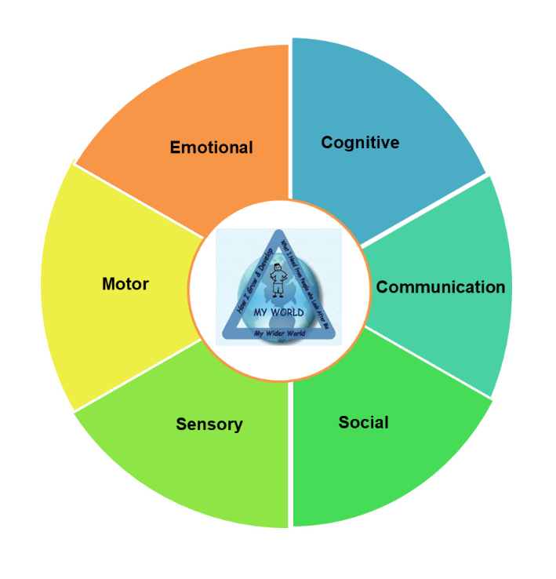

COMMUNICATION

Profile - Why might this be happening?
Questions to ask:
Did the child/young person understand what was expected?
Does the child/young person understand non-literal language?
Does the child/young person understand non-verbal communication (gestures, facial expressions, body language)?
Did the child/young person have enough time to process what was being said?
Is the child/young person able to express themselves verbally? If not, why not?
Is there another means whereby they could communicate- writing, visuals, gesture, typing/online
Return to wheel
Click or tap here to enter text.

SOCIAL

Profile -Why might this be happening?

Questions to ask:
Does the child/young person have difficulties with language and communication?
To what extent does the child/young person understand social rules and how to use them in the correct context?
Is the child/young person able to take the perspective of another?
Can the child/young person regulate their own behaviours/impulses?
Can the child/young person infer the intentions of others?
Is the child/young person able to adapt their behaviour to varying contexts?
Can the child/young person regulate their emotions?
Is the child/young person motivated to interact with others?
Can the child/young person pay attention to an activity with others?
Is the child/young person anxious about eating in social situations?
Return to wheel
Click or tap here to enter text.

COGNITIVE

Profile - Why might this be happening?

Questions to ask:
Can the child/young person hold and manipulate information in their heads for a short period of time?
Is the child/young person able to organise themselves and their equipment?
Can the child/young person use a range of strategies to problem solve?
Can the child/young person show flexibility of thought and behaviour?
Can the child/young person control inappropriate impulses?
Can the child/young person attain, maintain or switch attention as required?
Return to wheel
Click or tap here to enter text.

SENSORY

Profile - Why might this be happening?

Questions to ask:
How long can the child/young person focus for?
Is the child/young person distracted by things going on around them?
Is the child/young person able to deal with all the “sensations” associated with the activity?
Is the child/young person seeking sensory input (touch/taste/visual/auditory/movement)
Is this the first time the child/young person has attempted this activity, or do they have previous experience (positive or negative)?
Is the activity too long/complex for the child/young person?
Return to wheel
Click or tap here to enter text.

MOTOR

Profile - Why might this be happening?

Questions to ask
Does the child want to learn the activity?
Do they understand what they are being asked to do?
Do they have enough regular opportunities to practice the skill in a suitable environment?
Is the child struggling with: planning, doing, evaluating, or repeating the activity?
What stops them practicing more – can you change this?
Are they improving with practice, are they making the same mistakes repeatedly?
Could you adapt the activity for them or use equipment to make it easier?
Is the child tired or sore - does this need a medical review?
Return to wheel
Click or tap here to enter text.

EMOTIONAL

Profile – why might this be happening?

Questions to ask
Does the child/young person recognise emotions in themselves and others?
Does the child/young person have good strategies to manage big emotions?
Does the child/young person have good social understanding? ​
Does the child/young person fully understand the social or task expectations? ​
Can the child/young person follow the instructions?
Can the child/young person cope with unexpected change or lack of predictability​?
Is the child/young person able to stay focused on task​?
Is the sensory environment overwhelming?
Is the child/young person well rested and eating well?
Return to wheel
Click or tap here to enter text.

PLAN: How can I support?
What has already been tried? What worked and didn’t work?
Click or tap here to enter text.

What else can I do to support the child? Think about interactions, activities and environment.
Click or tap here to enter text.

Click or tap here to enter text.
What can others (for example family, school, other agencies etc) do to support the child?

Who can support me to make these changes?
Click or tap here to enter text.

